Post 1300 AD Architecture

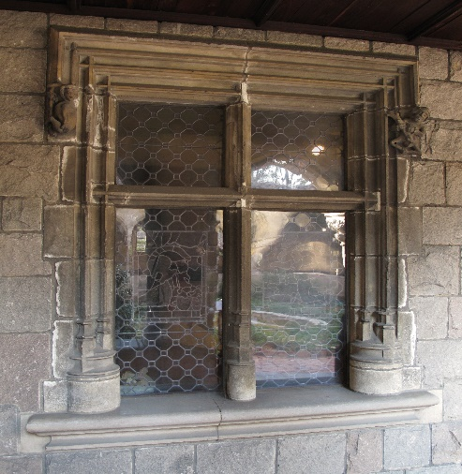
Window Frame
Date: 15th century
Geography: France
Culture: French
Medium: Stone
Dimensions: 104 3/4 x 109 3/4 in.
Classification: Sculpture-Architectural
Credit Line: Gift of Jacques Seligmann, 1909
Accession Number: 09.145a-k
This artwork is currently on display in Gallery 12

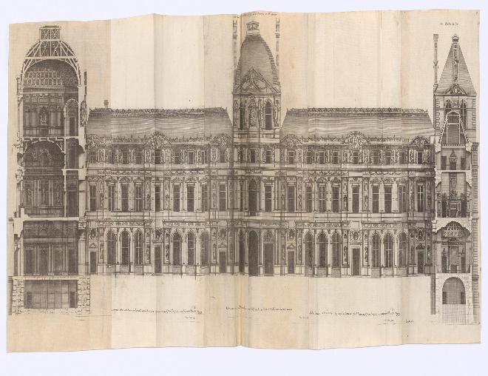
Architecture de Marot: Le Grand Marot (Set A)
Architect: Jean Marot (French, Paris 1619–1679 Paris)
Date: 17th century
Culture: French
Medium: Illustrations: engraving
Dimensions: 18 3/8 × 12 1/16 × 1 15/16 in. (46.6 × 30.6 × 5 cm)
Classification: Books, Ornament & Architecture
Credit Line: Rogers Fund, 1952
Accession Number: 52.519.185
This artwork is currently not on view

Write here about what about the two artworks interested you, and why you have chosen them for your comparison.

[ATTACH YOUR ADMISSION RECEIPT TO THE METROPOLITAN MUSEUM OF ART]

Reason for the selection
The primary reason for selecting the two pieces is my love for architecture. Architectural designs communicate a lot about a community’s cultural, political, religious, and economic practices. It also makes it possible to discern the environmental factors that impacted their way of life. Eiffel Towers in Paris is one of the iconic manmade structures, hence the curiosity to understand the historical background of French architecture. France is architecturally a unique country with a rich history in design. The design of Eiffel towers reflects the history of French architecture in different ways. Griggs (2020) note that the Early Gothic style, characterized by a long pointed arch, was the dominant design in Northern France. The Eiffel Towers depicts the French ancient architectural design as it takes the shape of a long-pointed arch. It is impossible to appreciate the significance of the tower without looking at the history of French designs. The assignment provided an opportunity to explore the richness of French architect history.
The two pieces of work capture the designs in different stages of French history. The first piece shows a window frame design in the 15th century. The frame has several features reflecting on the lifestyle and advancement of the culture’s advancement in building technologies. It has what appears like a wire mesh covering the entire window. The use of wire mesh to cover the window can imply that the designer was wary of the security situation, thus enhanced security. The window’s wooden frame is also a masterpiece of art, especially its smooth finishing. Also, its frames are big, which reflects the weight of materials used in building construction at the time.
In the second picture, the artist portrays a multi-story building in the 17th century. Interestingly, the design of the building is still common in some parts of French cities, which indicates the influence of past centuries on modern houses. The work captures various aspects of architectural designs, which contrast the first image. Firstly, the shapes of the windows in the second are different from the first. They are arch-shaped on top, whereas the 15th-century design was a solid rectangular shape window. Secondly, the windows in the 17th-century image are large. The change in the size of the windows was possibly influenced by the desire to enhance the lighting of the rooms. Notably, electric connectivity in the 17th century was limited, hence the increase in window frames to improve lighting. Both pieces have solid large frames, indicating the use of heavy materials in construction.

Reference
Griggs, N. C. (2017). Reconsidering the Tribune in Early Gothic Architecture of Twelfth-Century Northern France. Columbia University.

